5.91: a) Let 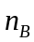 be the normal force between the plank and the block and 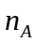 be the normal force between the block and the incline. Then, 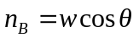 and 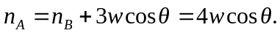 The net frictional force on the block is 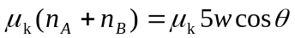. To move at constant speed, this must balance the component of the block’s weight along the incline, so 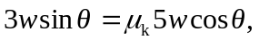 and 